Idlewild Elementary School



Family Handbook

2022-2023

Ms. Kiersten Schnacke, Principal

Dr. William Shuman, Assistant Principal

Idlewild Elementary

1950 Linden Avenue

Memphis, TN 38104

(901) 416-4566

FAX (901) 416-4492

Dear Idlewild Families and Friends,

Welcome to the beginning of a great new school year. This handbook, along with the district handbook, are designed to provide you with Idlewild policies and procedures. Reading it carefully with your child will make this a successful year for the entire Idlewild family.

If at any time you have questions, comments, or concerns please reach out to the school or schedule an appointment to speak with me directly. You may call the school at 901-416–4566.

Looking forward to a phenomenal year!!!!

Kiersten Schnacke

Principal

Idlewild Elementary School

*Idlewild Vision*

**We are Idlewild Leaders!**

•Every student is invested

•Every staff member makes a positive impact

•Every family is engaged

•Every community member is connected

*Idlewild Mission Statement*

At Idlewild we **empower** learners, **develop** leaders, **celebrate** diversity.

*Idlewild Slogan*

Children first, EXCELLENCE always.

**Idlewild Elementary Guarantees**

Our School Guarantees the Following…

**THE EXPECTATIONS OF EFFECTIVE TEACHING ARE CLEARLY DEFINED AT MY SCHOOL**

Idlewild expectations are established as four instructional practices which include Performance Based Objectives, Academic Vocabulary, Gradual Release of Responsibility, and Writing and Manipulatives.

**WE SHARE A COMMON VISION AT IDLEWILD ELEMENTARY SCHOOL**

Our vision is:

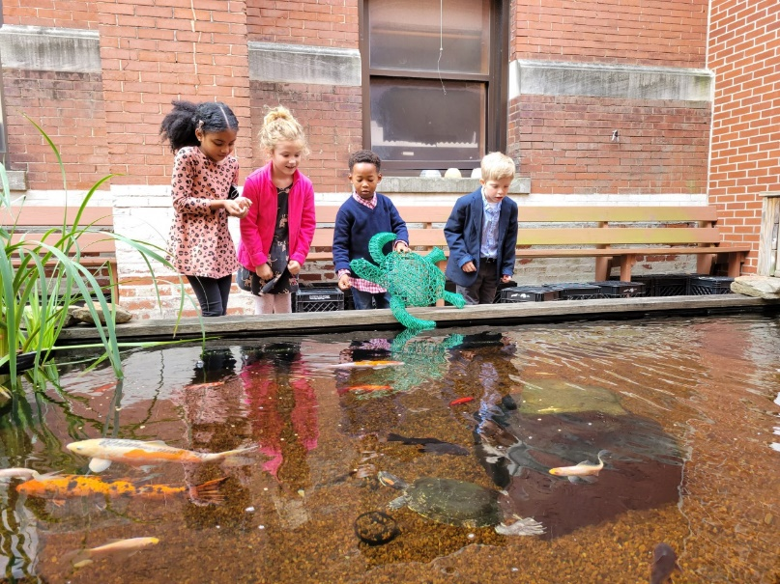•Every student is ***invested***

•Every staff member has a ***positive impact***

•Every family is ***engaged***

•Every community member is ***connected***

**THE ADMINISTRATIVE STAFF IS COMMITTED TO IMPROVING THE INSTRUCTIONAL PRACTICE OF ALL FACULTY & STAFF.**

PLCs, faculty meetings, sessions facilitation opportunities, & other leadership opportunities will guide our commitment to professional growth.

**WHO’S WHO IN THE OFFICE**

Principal Ms. Kiersten Schnacke

Assistant Principal Dr. William Shuman

Instructional Facilitator Ms. Joanna Byrnes

Professional School Counselor Mr. Franklin Collins

General Office Secretary Ms. Ronda Durr

General Office Secretary Ms. Patricia Jaimez

Financial Secretary Ms. Dottie James

Cafeteria Manager Ms. Evon Israel

Plant Manager Mr. John White

**School Website**

<https://schools.scsk12.org/idlewild-es>

**Social Media**

**Follow us on:**

**PTO Website:** [**https://www.idlewildoptionalpto.com/**](https://www.idlewildoptionalpto.com/)

***Together*, we MUST BELIEVE**

***Together*, we WILL ACHIEVE**

***Together*, we ARE** **REIMAGINING 901**

**School Mascot**

Eagle



**School Colors**

White, Royal Blue, and Navy

**Idlewild** **Elementary**

**School Wide Expectations**

We are the Idlewild Eagles soaring toward goals of excellence.

* Idlewild Eagles are: **Safe**
* Idlewild Eagles are: **Organized**
* Idlewild Eagles are: **Accountable**
* Idlewild Eagles are: **Respectful**

**The Idlewild Eagles will SOAR.**

**School Hours**

**MSCS Board Policy 6067 states it is the parent’s responsibility to ensure adequate supervision of their children before and after school hours.** There are no teachers/staff in the building to supervise the students prior to 7:45 a.m. Therefore, students may not enter the building or wait outside prior to that time **without parental supervision.**

Idlewild Elementary school hours of operation are **8:15 a.m. to 3:15 p.m.** with breakfast beginning at **7:45 a.m.** and concluding at **8:10 a.m.** for all students in the cafeteria.

* To assist you before and after care services are available through the YMCA and you may contact them at 901-766-7677 or enroll at <https://www.ymcamemphis.org/locations/child-care/learn.-grow.-thrive./>. In addition, Idlewild has partnered with Midtown Taekwondo for aftercare services, 901-725-5552 or at <https://www.midtowntaekwondo.com/>.
* All car riders and walkers must enter through the Main Door by the front marquee.
* Students must be picked up at 3:15 p.m. There will not be any school supervision after 3:30 p.m.

**Arrival/Dismissal**

Your child’s safety is a paramount concern to us. Please abide by these time frames. We are working to provide a safe environment for your child during the school year. We require your help in making the Idlewild Elementary campus accident free.

* Pull all the way up to the stop sign. This will allow the maximum number of cars to unload at a time, keeping our car rider line flowing.
* Your child should be ready to get out of the car as soon as you stop.  Please remain in your vehicle. If your child needs assistance, a staff member will be there to help.
* Put your car in PARK when you stop to let your child out and do not move forward until you are directed to do so by our staff.
* Students may only be dropped off in the car rider line. Please do not pull into any parking lots, driveways, or release students across Linden Ave. (South side of street). If you need to walk to the school building with your child, please park in one of the available parking spaces.
* Remind your child to get out of the car (if at all possible) on the RIGHT side of the car so that he or she will not have to come around in front of or back of the car out of your sight. IF your child must get out on the left-hand side of your vehicle, please have them walk around **in front** of your vehicle so that you can watch him or her go all the way around the car to the sidewalk.
* Remind your child to NEVER go back to the car if he or she has forgotten or dropped something. Often, drivers are unable to see children who run back toward cars.
* **BY LAW** and for the safety of all students and staff, the use of cell phones is prohibited inside a school zone and while operating a motor vehicle.

**At Idlewild Elementary, SAFETY IS OUR #1 PRIORITY!  We have nearly 600 students who go home each afternoon several different ways (car riders, walkers, bikers, etc.). Our main goal is to keep each child safe by making sure they are dismissed per their parent’s instructions to a location with appropriate supervision. In order to allow us to continue to support each parent’s dismissal plan, please continue to uphold the following dismissal-related procedures:**

1. ALL early checkouts at Idlewild stop at 2:30 each day. This means that if you attempt to check out a student between 2:30 and 3:00, you will be directed to get back in the car rider line and we will dismiss your child to you as part of our regular car rider dismissal procedure starting at 3:05. If you need to check your child out of school early for an appointment, please do so no later than 2:30.
2. If your child needs to go home a different way than usual, contact the teacher IN WRITING, either by written note or digitally through Class Dojo or email. If a need arises throughout the day for you to change your student's dismissal plan, call the school office by 2:00. It takes a considerable amount of time to dismiss our entire student body and the last hour of the school day is by far our busiest time. The later we get the information, the greater the likelihood a miscommunication could occur. Again, our students' safety is our #1 priority - please help us by being as prepared as possible.
3. Cars will not be permitted to park or wait in front of the building until 3:00 in order to provide clear and immediate access to the school for first responders in the event of an emergency.  Thank you for your help and understanding in this matter.

***\*Parents of younger children: In an effort to expedite dismissal, please help us by teaching your child to buckle themselves into their car seats independently. The disruption to the flow of traffic when parents must get out of their vehicles to secure children in car seats delays our dismissal unnecessarily.***

1. Only those with Idlewild issued car rider tags will be permitted to pick up an Idlewild student in the car rider line. If there is no tag, you will be asked to park while we verify your identity as someone who has been identified in Powerschool as a verified individual by the guardian as allowed to pick up their child. This will require a state issued ID. If you need a car tag, call the school office.

**As always, thank you for assisting us in making your child’s school day as safe as possible. If you have any questions or concerns about these procedures, please contact us at 901-416-4566.**

**Car Rider Pickup Line**

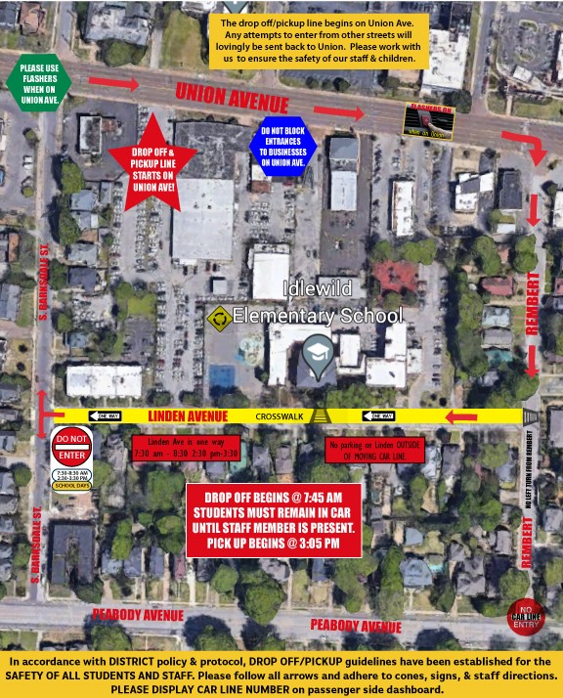

**Suggested Walker/Biking Routes**

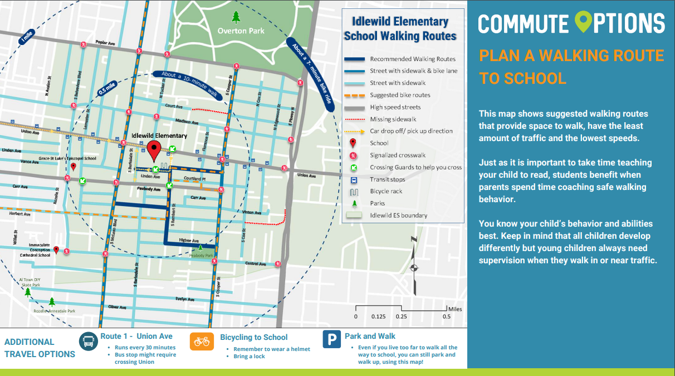

**School Dress Code**

The Shelby County Schools Policy on Dress Code (#6021) requires all students to wear the school uniform every day.

* **Boys:** Navy, Khaki, or Black pants or shorts Royal, navy, light blue, or white polo or button down shirts (collared)
* **Girls:** Navy, Khaki, Black or Idlewild Plaid skirts, pants, shorts, or jumpers Royal, navy, light blue or white polo or button down shirts (collared)
* Skirts and dresses must be at or below the knee. Leggings worn under skirts and dresses must be uniform colors.
* Tennis shoes are required for physical education. Students may not wear flip-flops or any type of shoe that has an open back.
* Hats are for outside wear and must be removed when entering the building, unless there is a medical reason or a special spirit day. All jackets, sweaters, and sweatshirts that isn’t Idlewild spirit wear worn during the day should be solid Navy, Royal Blue, Light Blue, or White.
* Idlewild spirit wear can be worn daily, visit the [PTO website](https://www.idlewildoptionalpto.com/) to purchase.

**Visitors/Volunteers**

Parents and other visitors are welcome to visit our school. All visitors must report to the office. Visitors must wear a visitor badge or name tag issued by the office.

Visits to individual classrooms during instructional time are permitted only by scheduled approval of administration and teacher. Such visits are not permitted if their duration or frequency interferes with the delivery of instruction or disrupts the normal school environment.

Parents of Kindergarten students are able to walk their students to class during the staggered entry day. Please park on the west side of Linden beyond the school. If you need to speak with your child’s teacher, we request that you schedule an appointment via email or Classdojo. **A forgotten item (such as a lunch box) should be brought to the office, and the child will be called to pick it up.**

We are grateful for the many volunteers that serve our teachers and students each day. In order to be in compliance all volunteers in Memphis-Shelby County Schools are required to go through one of the three levels of clearance. In order to complete the process, please [follow the link](http://www.scsk12.org/face2/?pn=Volunteers&sm=3) to the district website.

**Field Trips**

Field trips are planned experiences that provide students with insight, information, and knowledge that constitute an extension of the regular classroom instruction. Each field trip shall be supervised by school personnel at a minimum of one adult for every twenty children for in-town field trips and one adult for every nine students for out-of-town field trips. There are cases where the classroom teacher may request greater supervision.

Signed parental permission forms must be obtained for each student in order to leave campus. In an emergency, a faxed or e-mailed permission slip will be accepted. All parents must complete the approved MSCS Volunteer to participate in the field trips.

Students who have earned N or U for weekly conduct, on progress reports, or report cards can forfeit the opportunity to participate on field trips. For safety reasons, we may require a parent to accompany their child on a fieldtrip if he/she is experiencing difficulties.

**Parent Communication**

Teachers utilize Class Dojo, and during Gear Up Day (August 2) parents can receive information about logging into Class Dojo.

If there is a classroom concern it please address it with the appropriate classroom teacher by using Class Dojo, calling, or emailing the teacher directly. If all parties are not satisfied, a conference with an administrator may be requested. Schedule an appointment by callingthe school’s office at 901-416-4566 so that we can serve you in a timely manner. Special circumstances or social emotional issues should be addressed directly with the School Counselor.

It is imperative that parents inform the school of any address or telephone number changes. In the event of an emergency, the school must have accurate information to make phone contact. This should include home, work, cell phone, and emergency friend’s telephone numbers.

A key component of the school administration communication partnership with parents is the utilization of phone calls or emails via the Blackboard messaging system, Class Dojo, and the biweekly Parent and Community Edition of the Talon Talk, and a monthly calendar. Individual teachers will communicate via Class Dojo, Tuesday Folders, and grades posted weekly in the Powerschool Parent Portal.

**Conferences**

Parent-teacher conferences can be scheduled as needed and initiated by the parent or teacher. Any time you would like to meet your child’s teacher, an appointment must be scheduled via email or Class Dojo*.* If there is an immediate concern, please reach out to our school counselor ([collinsfa@scsk12.org](mailto:collinsfa@scsk12.org)) or call the main office at 901-416-4566. Drop-in conferences or visits are discouraged because they interrupt classroom routines and instruction for all students.

All teachers have daily planning to accommodate returning phone calls and emails. Many teachers use this time to plan for their instructional blocks so please allow 24 hours for a response. ***Teachers will not be called to the phone to talk to a parent during instructional time.***

**District Scheduled Parent Teacher Conferences –** September 8th and February 16th from 4:00p.m. to 7:00p.m.

**Idlewild Elementary School**

**Faculty & Staff Roster**

**2022-2023**

|  |  |  |  |  |
| --- | --- | --- | --- | --- |
| **Title** | **Name** | **Room Number** | **Content Area** | **Email Address** |
| **PRINCIPAL** | KIERSTEN SCHNACKE | MAIN OFFICE |  | [schnackemeyerk@scsk12.org](mailto:schnackemeyerk@scsk12.org) |
| **ASST. PRINCIPAL** | WILLIAM SHUMAN | ACROSS FROM OFFICE |  | [shumanwe@scsk12.org](mailto:shumanwe@scsk12.org) |
| **GUIDANCE** | FRANKLIN COLLINS | 400 |  | [collinsfa@scsk12.org](mailto:collinsfa@scsk12.org) |
| **PLC COACH** | JOANNA BYRNES | 231 |  | [byrnesj@scsk12.org](mailto:byrnesj@scsk12.org) |
| **INTERVENTIONIST** | ROBIN HARGETT | LIBRARY OFFICE |  |  |
| **GOS** | RONDA DURR | MAIN OFFICE |  | [durrrl@scsk12.org](mailto:durrrl@scsk12.org) |
| **GOS** | PATRICIA JAIMEZ | MAIN OFFICE |  | [jaimezp@scsk12.org](mailto:jaimezp@scsk12.org) |
| **FIN. SEC.** | DOTTIE JAMES | ACROSS FROM OFFICE |  | [jamesdr@scsk12.org](mailto:jamesdr@scsk12.org) |
| **PLANT MANAGER** | JOHN WHITE | 260 |  | [whitej14@scsk12.org](mailto:whitej14@scsk12.org) |
| **CAFETERIA MANAGER** | EVON ISRAEL | CAFETERIA OFFICE |  | [israele@scsk12.org](mailto:israele@scsk12.org) |
|  |  |  |  |  |
| K-01 | PATRICIA KNIGHT | 106 | Self-contained | [knightpc@scsk12.org](mailto:knightpc@scsk12.org) |
| K-02 | CARLY MORGAN | 108 | Self-contained | [morgancf@scsk12.org](mailto:morgancf@scsk12.org) |
| K-03 | STEPHANIE SACCO | 110 | Self-contained | [saccosm@scsk12.org](mailto:saccosm@scsk12.org) |
| K-04 | JADA TURNER | 104 | Self-contained | [turnerjr@scsk12.org](mailto:turnerjr@scsk12.org) |
| K-05 | GRAYSON MCENIRY | 103 | Self-contained |  |
|  |  |  |  |  |
| 01-01 | JANICE JONES | 102 | Self-contained | [jonesj4@scsk12.org](mailto:jonesj4@scsk12.org) |
| 01-02 | MALLORY KEY | 204 | Self-contained |  |
| 01-03 | MCKENZIE NOBERT | 206 | Self-contained | [nobertm1@scsk12.org](mailto:nobertm1@scsk12.org) |
| 01-04 | CONSTANCE NATHAN | 100 | Self-contained | [nathancb@scsk12.org](mailto:nathancb@scsk12.org) |
| 01-05 | JALETA MILLER | 205 | Self-contained | [millerjr@scsk12.org](mailto:millerjr@scsk12.org) |
|  |  |  |  |  |
| 02-01 | REBECCA HOLCOMB | 211 | Self-contained | [sheltonra@scsk12.org](mailto:sheltonra@scsk12.org) |
| 02-02 | LAUREN RITTER | 210 | Self-contained | [hopperl@scsk12.org](mailto:hopperl@scsk12.org) |
| 02-03 | ADAM BRASSFIELD | 209 | Self-contained |  |
| 02-04 | LORI PARSLEY | 208 | Self-contained | [parsleylp@scsk12.org](mailto:parsleylp@scsk12.org) |
|  |  |  |  |  |
| 03-01 | KRISTINA LAWRENZ | 304 | Self-contained | [lawrenzkg@scsk12.org](mailto:lawrenzkg@scsk12.org) |
| 03-02 | BRENT MICHAEL | 302 | Self-contained | [michaelb@scsk12.org](mailto:michaelb@scsk12.org) |
| 03-03 | BRITTANY WHITE | 308 | Self-contained | [whiteb2@scsk12.org](mailto:whiteb2@scsk12.org) |
| 03-04 | REBECCA TAYLOR | 300 | Self-contained | [taylorra@scsk12.org](mailto:taylorra@scsk12.org) |
| 03-05 | SHALONDA BLACK | 304 | Self-contained | [blacksl@scsk12.org](mailto:blacksl@scsk12.org) |
|  |  |  |  |  |
| 04-01 | HANNAH MCTIERNAN | 312 | ELA | [mctiernanh@scsk12.org](mailto:mctiernanh@scsk12.org) |
| 04-02 | ANGELA HARVEY | 310 | Math | [harveyan@scsk12.org](mailto:harveyan@scsk12.org) |
| 04-03 | DAVID BOWLIN | 315 | Science | [bowlind@scsk12.org](mailto:bowlind@scsk12.org) |
| 04-04 | ALLISON OTTING | 311 | SS/Writing | [ottinga@scsk12.org](mailto:ottinga@scsk12.org) |
|  |  |  |  |  |
| 05-01 | HANNAH BARBER | 206 | Math | [mimsh@scsk12.org](mailto:mimsh@scsk12.org) |
| 05-02 | JOURDAN REDDEN | 202 | ELA | [reddenjs@scsk12.org](mailto:reddenjs@scsk12.org) |
| 05-03 | PATRICIA BONE | 200 | Science/Social Studies | [bonep@scsk12.org](mailto:bonep@scsk12.org) |
|  |  |  |  |  |
| MUSIC | ALLEN MOODY | 212 | Music | [moodya@scsk12.org](mailto:moodya@scsk12.org) |
| MUSIC | CARRINGTON TRUEHART | 212 | Music | [truehartc@scsk12.org](mailto:truehartc@scsk12.org) |
| MUSIC | CLIFTON BRADY | 212 | Music | [bradycd@scsk12.org](mailto:bradycd@scsk12.org) |
| ART | EMILY CHAMBERS | 214 | Art | [Graychamberse1@scsk12.org](mailto:Graychamberse1@scsk12.org) |
| ART | JOSHLYNN WILLIAMS | 214 | Art | [Williamsj47@scsk12.org](mailto:Williamsj47@scsk12.org) |
| P.E. | JESSICA KING | GYM – PE OFFICE | P.E. | [kingje2@scsk12.org](mailto:kingje2@scsk12.org) |
| P.E. | TBD | GYM – PE OFFICE | P.E. |  |
| LIBRARY | KIM BUIE | LIBRARY | Library | [buiekd@scsk12.org](mailto:buiekd@scsk12.org) |
| TECHNOLOGY | LISA GRAVES | LIBRARY | Optional – Tech. | [graveslb@scsk12.org](mailto:graveslb@scsk12.org) |
| SCIENCE LAB | ERIN PAULEY | 216 | Optional – Sci. | [pauleye@scsk12.org](mailto:pauleye@scsk12.org) |
| SPANISH | KAYLA HINES | TBD | Spanish | [hineskj@scsk12.org](mailto:hineskj@scsk12.org) |
|  |  |  |  |  |
| CLUE | JILIAN ATLAS | 332 | CLUE | [atlasj@scsk12.org](mailto:atlasj@scsk12.org) |
| CLUE | MARYBETH TOES | 309 | CLUE | [toesm@scsk12.org](mailto:toesm@scsk12.org) |
| CLUE | JACOB CLINE | 218 | CLUE | [clinej@scsk12.org](mailto:clinej@scsk12.org) |
|  |  |  |  |  |
| INSTRUCTIONAL RESOURCE | CHASSITY CLEAVER | GYM - CLASSROOM | SPED | [smithc10@scsk12.org](mailto:smithc10@scsk12.org) |
| FUNCTIONAL SKILLS | MICHELLE PUHEK | 110 | SPED | [puhekml@scsk12.org](mailto:puhekml@scsk12.org) |
| ESL | JENNIPHER TIMS | 110 | ESL | [timsj@scsk12.org](mailto:timsj@scsk12.org) |
|  |  |  |  |  |
| SPECIALIZED ED. ASST. | KEMBA MAAT | KINDERGARTEN |  | [maatk@scsk12.org](mailto:maatk@scsk12.org) |
|  | LINDA TOMPKIN-WELLS | KINDERGARTEN |  | [tompkinswellsl@scsk12.org](mailto:tompkinswellsl@scsk12.org) |
|  | CHIQUITA SNERLING | 1st GRADE |  | [snerlingc@scsk12.org](mailto:snerlingc@scsk12.org) |
|  | TERRY THORNTON | 1st GRADE |  | [thorntont1@scsk12.org](mailto:thorntont1@scsk12.org) |
|  | LINDEN BUMP | 2nd GRADE |  | [bumplk@scsk12.org](mailto:bumplk@scsk12.org) |
|  | CHRIS DERVAUX | 2nd GRADE |  |  |
|  | JONATHAN DUNCAN | 2nd GRADE |  |  |
|  |  |  |  |  |
| EDUC. ASST. | LEMETRIA FAULKNER | 3rd/4th/5th GRADE |  | [faulknerlf@scsk12.org](mailto:faulknerlf@scsk12.org) |
|  | CHRISTOPHER WICKS | CONFERENCE RM. |  | [wicksc@scsk12.org](mailto:wicksc@scsk12.org) |
|  |  |  |  |  |
| SPECIAL ED. ASST. | JEAN TERRELL | 304 |  | [terrellje@scsk12.org](mailto:terrellje@scsk12.org) |
|  | STEPHEN MCINTOSH | 110 |  | [mcintoshsb@scsk12.org](mailto:mcintoshsb@scsk12.org) |
|  |  |  |  |  |
| SPEECH THERAPIST | ANNA GABRIEL | LIBRARY - OFFICE |  | [gabrielac_ec@scsk12.org](mailto:gabrielac_ec@scsk12.org) |
| SOCIAL WORKER | KAREN BUCK | LIBRARY - OFFICE |  | [buckh@scsk12.org](mailto:buckh@scsk12.org) |
| SCHOOL PSYCHOLOGIST | ERIC PAPINEAU | CONFERENCE RM. |  | [papineaue@scsk12.org](mailto:papineaue@scsk12.org) |

**Cell Phones and Electronics**

Your child is permitted to bring a cell phone to school as long as it remains off and in the student’s backpack. Toys and electronic gaming devices should not be brought to school. **The school is not responsible for theft, loss or damage of personal devices brought to school.** Confiscated items will be returned to the student’s parent/guardian within 72 hours during a conference with an administrator.

**Birthday Parties**

We realize that birthdays are major events in the life of a child. Student birthdays will be acknowledged daily during school announcements. Parents please do not send invitations to school or distribute them in the classroom unless all students in the classroom are invited. If you would like to help your child celebrate their birthday with all of their classmates, the distribution of a small “treat” bag of pencils, erasers, stickers, etc. is recommended. Please refrain from bringing balloons. Any food items should be prepackaged and adhere to student classroom allergy need. Please contact the classroom teacher for further guidance. Birthday “treat bags” will be distributed to students at dismissal by their classroom teacher.

**Cafeteria**

#### All MSCS students receive universal Breakfast and Lunch free of charge. When weather permits students at Idlewild can eat outside at the picnic tables with supervision. Due to the limited space available within our historic building and timing of our lunch schedules to serve all students within a reasonable lunch hour we are unable to accommodate guests during student lunches. All food brought into the school from the outside must be consumed within the cafeteria (ex. Chick Fil-A, Starbucks, etc.)

**Cafeteria Conduct**

* All students in the school share the cafeteria therefore we promote student leadership in keeping their area neat and clean. Students are expected to maintain behaviors as it relates to the schoolwide expectations (SOAR).

**Food Allergies**

* All your student has food allergies that staff needs to be aware of please visit the main office to complete the necessary paperwork. In addition, please also discuss this with your child’s homeroom teacher.

**Attendance**

Tennessee State law requires that all children between the ages of six (6) and seventeen (17) attend school. Regular and punctual attendance is imperative. Higher academic achievement occurs when students attend classes regularly. Optional students may not accumulate more than 15 absences, early dismissals or tardies (combined). Students who exceed this number will be placed on Optional Probation and are at risk for losing their Optional Status.

**Steps to Follow When Students Are Absent:**

1. Parent notifies classroom teacher/front office if the absence will extend beyond one day.
2. Parent or guardian must write an excuse indicating the date, days of absence, reason for absence, and include his or her signature.
3. Submit the excuse to the homeroom teacher when the student returns.

**Excused Absences**

1. Illness or hospitalization of student. (Anytime a student is out for 3 or more consecutive days, a doctor’s statement will be required.After the accumulation of 10 excused days, all absences will require a physician’s statement to be excused.)
2. Death or serious illness in the immediate family
3. Validated court appearance of the pupil
4. Recognized religious holiday / event

**Unexcused Absences**

A student who accumulates 5 days of unexcused absences will be given notice to attend a Student Attendance Review Team meeting with the school counselor at which time a plan will be set in place to help with future attendance. After 10 unexcused absences, notice will be given to attend a meeting with the Memphis-Shelby County Truancy Liaison.

**Tardies**

Students reporting to homerooms after 8:15 a.m. are marked tardy and must have a tardy slip from the office. Exceptions will be made by administration if drop off lines exceed normal times due to accidents, weather, or heavy traffic. Tardy students must be accompanied into the building and must be signed in by an adult in the main office. Tardies follow the procedures for unexcused absences.

**Early Dismissal**

We know that sometimes appointments cannot be scheduled outside of the school day. However, we encourage you to limit the number of early pickups. Students will only be called down for dismissal when parents arrive to sign students out. Please allow enough time for students to gather their things and walk to the office. Dismissal is one of the busiest points of the day and to ensure that all students are safely dismissed there will be no early student dismissals after 2:30 p.m..

**Emergency School Closing**

Please make advanced arrangements in case of early dismissal due to weather. If school is closed due to bad weather, the Superintendent of Schools will notify local TV and radio stations that will broadcast the information. The school will notify families via one of the identified communication methods (Class Dojo/Blackboard). People are not listed on the student information form will not be allowed to check-out your children.

**Health Policies**

All students are required by the state to have updated immunizations on the State Health Form on file. Parents will be notified in cases of illness and / or injury**.** Parents should notify the school on any updates regarding address, telephone numbers and emergency contacts.

Any child who has a temperature of 100.4 or more must be picked up. **A child must be free of fever for 24 hours before returning to school.**

Students will not be allowed to remain at school if one or more of the following exists:

* If the illness prevents the child from participating comfortably in school
* If the illness results in greater need for care than the staff can provide without compromising the health, safety, and supervision of the other students
* Oral temperature of 100.4 degrees or greater

To return to school after the following, the child must bring proof of treatment to the office.

* Chicken pox (child must be excluded until blisters are scabbed over completely)
* Hepatitis A (child must be excluded until one week after jaundice appears or one week after the illness started and fever is gone)
* Pink Eye (child is excluded until treatment has begun and discharge has stopped)
* Undiagnosed Generalized Rash
* Head Lice (child is not to return to school until lice are no longer present)
* Measles (child must remain at home until four days after the rash appears)
* Mumps (child must not return for nine (9) days or until swelling subsides)
* Ringworm (child should not return to school until treatment is started and lesion is covered)

**Medications**

Only medications that absolutely must be given during the school hours should be brought by a parent or guardian to the office. Students receiving medication at school must follow these guidelines:

* All medication must be brought immediately to the Main Office by the parent/guardian.
* Medication must be in the original container with a pharmacy label, and must have the student’s name, amount of dosage, and
* frequency/time of dosage.
* Approved possession of a student’s own prescription medication during the school day is limited to life threatening conditions.
* Medication may only be dispensed through the office or clinic (EPI pens and inhalers are exempt).
* The desired plan for usage of EPI pens is for the parent to provide 2 pens, one will be kept in the school office, and one will be kept in the student’s classroom. *Aspirin, Tylenol, cough drops and other non-prescriptions items will not be given to children during school hours. School personnel will not administer shots or injections.*
* Any questions regarding students and medication will be handled through the School Nurse.

**Covid-19 Policies**

Currently, the CDC recommends that **positive cases isolate for a minimum of five (5) days after the onset of symptoms**. Cases may be released from isolation after they are without fever for 24 hours (without fever-reducing medication) and show improvement in symptoms. Regardless of symptoms, the CDC recommends wearing a well-fitting mask when around others for ten (10) days following the onset of symptoms or specimen collection.

**UPDATED QUARANTINE PROTOCOL**

* Under the new emergency rule, the TDOH allows school districts to adopt their own quarantine guidance. As a result, MSCS will adhere to the following protocol: ***asymptomatic* staff or students identified as close contacts with a COVID-positive person are no longer required to quarantine**. These individuals should self-monitor for signs and symptoms for ten (10) days following exposure. If no symptoms develop, TDOH recommends getting a COVID test on or after day five (5). In the event staff or students identified as a close contact with a COVID-positive person becomes *symptomatic*, it is recommended that the individual test immediately and quarantine until test results are received. Individuals who receive a positive test are to isolate and follow recommendations for positive cases.

**Covid-19 Testing**

Beginning Monday, August 8, 2022, MSCS in partnership with PathAI Diagnostics, formerly known as Poplar Healthcare, will open asymptomatic COVID testing sites that will be open Monday through Friday 10:00 am to 6:00 pm at the following locations:

Booker T. Washington

715 S. Lauderdale St.

Memphis, TN 38126

Cordova Middle School

900 Sanga Rd.

Memphis, TN 38018

Manassas High School

1111 Manassas

Memphis, TN 38107

Testing will be available for all **active** MSCS employees and students. To participate in this year’s testing program, please visit <https://tinyurl.com/m-scscovidtest22-23> to complete your registration. Note: everyone must complete a new registration for the 2022-23 program regardless of participation last year. **Registration opens on Friday, August 5, 2022** and should be completed prior to arriving at one of the designated sites to be tested.

Link to register for testing:

Original URL: <https://covid.poplarhealthcare.com/s/bAssessment?RRAccount=0014R000039DJ7l>

Shortened URL: <https://tinyurl.com/m-scscovidtest22-23>

Should you run into issues registering for testing on or after August 5, 2022, please email your First Name, Last Name, Date of Birth and school you are associated with to [covidtesting@scsk12.org](mailto:covidtesting@scsk12.org), or call 901-271-2671.

**Social Emotional Concerns**

Idlewild Elementary has on staff a Professional School Counselor who helps children when problems get in the way of their happiness and ability to do well in school. Our Counselor works with children in classes, small groups or individually to help them:

* Adjust to school
* Practice good study skills and work habits,
* Improve communication skills,
* Learn to cooperate,
* Solve problems,
* Make good choices, AND
* Prepare for future careers.

Our Professional School Counselor also provides support for children who are experiencing academic difficulties, health conditions, behavioral issues or personal concerns which are affecting their ability to be successful. Contact Mr. Franklin Collins (901-416-4566, collinsfa@scsk12.org) for more information. Students may be referred for services by parents, teachers, and school administrators or by the students themselves.

In addition, Idlewild has several other mental health professionals on campus throughout the week who provide services to students who need further evaluation and support. These include School Psychologist (Mr. Eric Papineau), Social Work (Ms. Karen Buck), Speech (Ms. Anna Gabriel), and Occupational Therapist (Ms. McKenzie Hanna).

**Parent Teacher Organization**

The Idlewild Elementary Parent Teacher Organization (PTO) provides physical, financial, emotional, and educational support of the students, faculty and staff of Idlewild. Idlewild PTO promotes school pride, informs parents and encourages school participation. Our PTO is a vital part of our school and organizes the opportunities for parents to volunteer in the school.

Parents can get updates via the PTO website: <http://www.idlewildpto>.org or ask questions on our PTO’s Facebook page at **Idlewild Optional School PTO** and/or Twitter account @**IdlewildPTO**.

**Lost and Found**

If your child should lose any articles, he/she is to report the loss to the classroom teacher. There is a lost and found shelf in the cafeteria hallway. **Please** **label all coats, caps, and book bags to make identification easier**. All articles of clothing or other items not claimed at the end of each semester will be donated to our PTO uniform drive or charity each semester.

**Safety Drills**

Idlewild conducts safety drills in accordance with state law. Please spend some time at home discussing the importance of safety drills and use the opportunity to practice safety drills within your own homes. If parents or other visitors are at school during a drill, they will be expected to participate in the ongoing drill.

Below are the minimums required, but at times additional drills can be scheduled. All staff members participate in training during in-service and faculty meetings.

* Fire Drills are conducted monthly. Some require full evacuation of the school, while others are read during morning announcements.
* Shelter in Place and Tornado drills are conducted twice yearly.
* Lock Downs are conducted twice yearly.
* AED inspections are conducted one per month and there are at least 5 faculty members CPR certified each year.

**Library Open Checkout**

The school library is open each day from 8:00-8:20am for open checkout. This year students will have library every other week in collaboration with our optional programming, technology.

**Grading Policy**

**Memphis-Shelby County School’s system for determining academic grades is as follows:**

Excellent A 90-100

Good B 80-89

Average C 70-79

Low Average D 60-69

Failure F 59-0

Conduct Grades:

Excellent E

Good G

Satisfactory S

Needs Improvement N

Unsatisfactory U

For more information please see [Board Policy 5014](https://go.boarddocs.com/tn/scsk12/Board.nsf/files/CFUK8H4ECF1E/$file/5014%20Grading%20System%20for%20Grades%20Pre-K-5%20.pdf)**.**

**Idlewild Elementary Family Handbook 2022-2023**

**Signature Page**

**Student Name:____________________________ Teacher Name:________________________ Grade:____________**

**Parents, please initial all statements after you read through them and return this page to your child’s teacher within five (5) school days.**

_____(Student Initials) I understand the contents of the Idlewild Student Family Handbook and agree to work in partnership with my teachers, administrators, and my parents.

_____(Parents Initials) I understand the contents of the Idlewild Student Family Handbook and agree to work in partnership with my students’ teachers, administrators, and school community.

|  |  |
| --- | --- |
| Student’s Signature: |  |
| Print Parent’s Name: |  |
| Parent’s Signature: |  |
| Date: |  |

